Accessing Your Child’s Account and Switching Between Multiple Child Accounts
Account View  Click on the arrow in the upper-right corner, next to your name. | 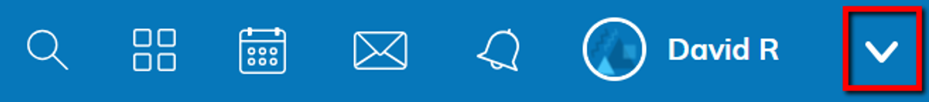
Connected Student Accounts  Below your name, you'll see the name(s) of the child(ren) associated with your account.  To view your child's activity, click the child's name from the dropdown menu. | 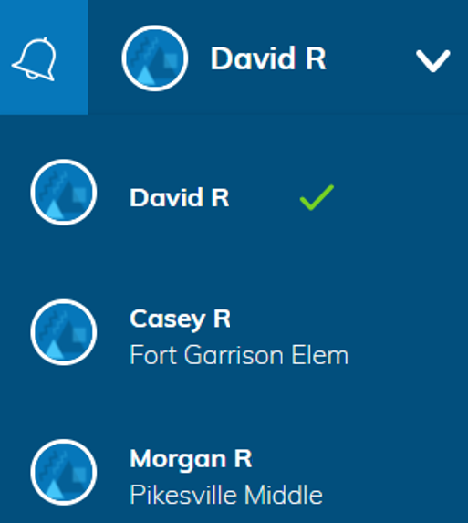
View Student Account  The check mark in the drop-down menu indicates which account you are currently in. | 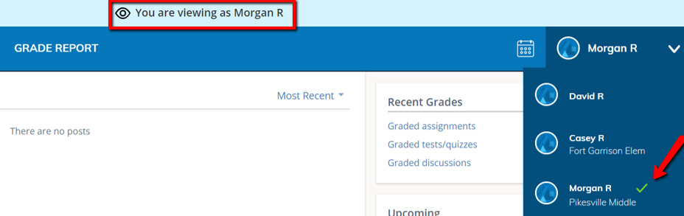
Student Account Activity  Selecting your child’s name will allow you to see activity in Schoology from your child’s perspective. | 