Navigating your Parent View in Schoology
Parent Home Page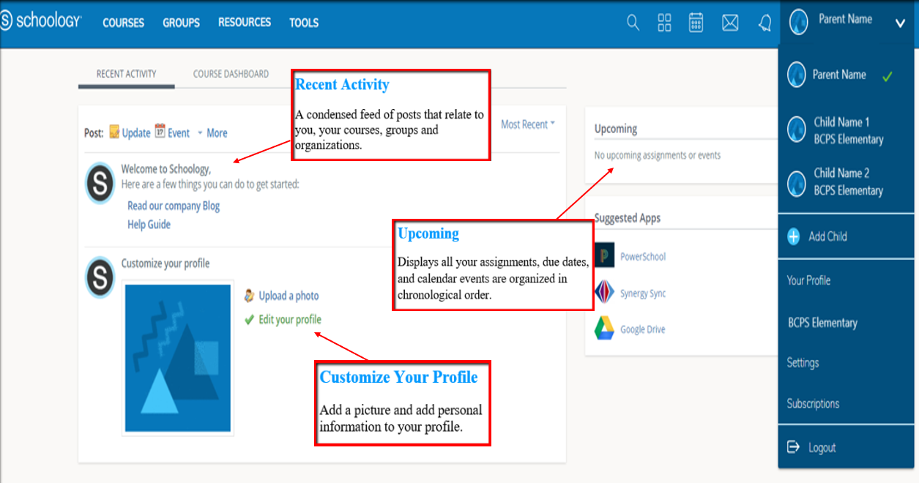

Course Dashboard

Course Dashboard enables you to view of your courses as a tiled list. Drag and drop course tiles to reorder courses. From the Course Dashboard, click into any one of your courses and go directly to its main landing page.
Account View  Click on the arrow in the upper-right corner, next to your name, to view any connected student account(s).  The check mark in this drop-down menu indicates which account you are currently in. | 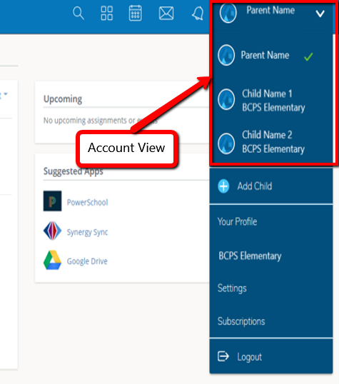
Setting Up Notifications  Click Settings from the drop-down menu in the upper right-hand corner. From the account settings area, click the Notifications tab to customize your notification settings. | 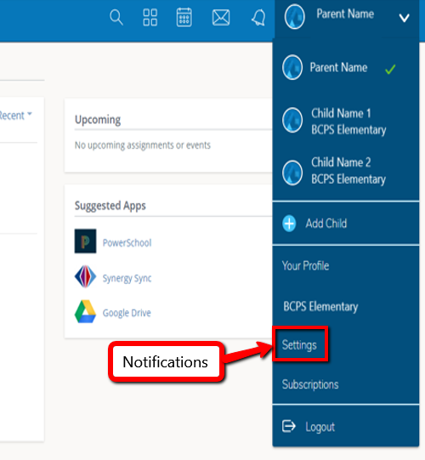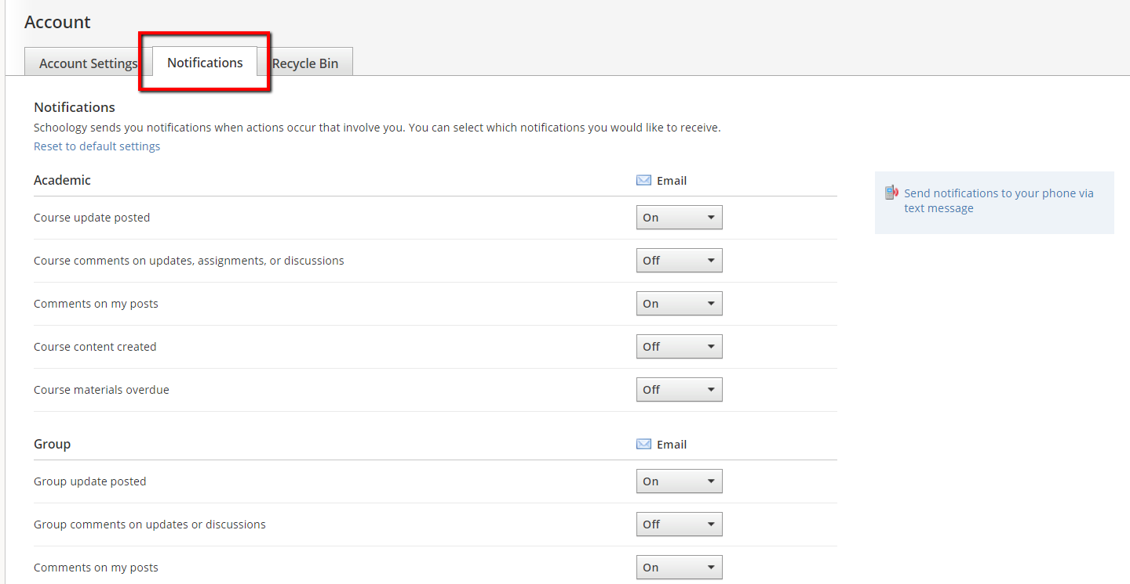
Search & Calendar  Search allows you to find courses, groups, and people in Schoology.  Calendar displays events from your courses, groups, and organizations. | 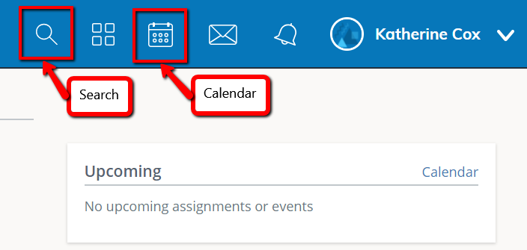
Messages & Notifications  Messages allow you to communicate with other BCPS Schoology users.  Notifications appear any time someone sends you a message, wants to connect, or does something that pertains to your courses or groups (depending on your settings). | 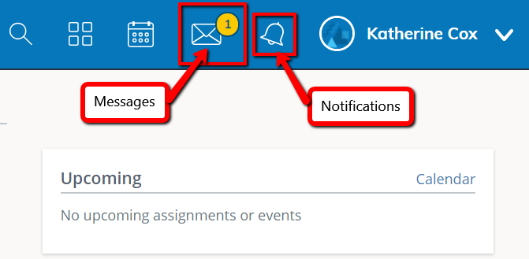
Courses, Groups, and Resources  Courses display courses in which you are personally enrolled.  Groups display the groups in which you are enrolled.  Resources are a place to create, view, edit, and manage all your instructional resources. | 